This is the final report on your implementation. Paste Assignments 1 - 5 at the head of this *as is*, except that in Assignment 5, respond to each of your facilitator’s comments within each of their comments. Again, retain these gray parts. Keep in mind the evaluation criteria (at the end) and that they are somewhat altered for this assignment. For voluminous material, reference appendices (at the end). These will be read on an as-needed basis. Excluding appendices and figures, this response should not exceed 6 pages—without prior permission.

MBTA rapid-transit arrival time prediction

by Amal Krishna

# PROJECT PROPOSAL WITH YOUR RESPONSES

Please insert your Phase 1 here, including my comments and your response within each comment.

# Project Proposal +

Please use this template; retain the gray text. Your phase 1 materials—in black 12-point Times New Roman—should not exceed 5 pages excluding references and figures.

## 1.1 SUMMARY DESCRIPTION

One- or two-paragraph overall description of your proposed semester project.

Using Machine Learning techniques on MTA/MBTA (NYC/Boston) subway real-time plus past data-sets to predict arrival times, prevent train-bunching and reduce wait times. Even though I don’t have everything planned out my main objective is to predict arrival times and subway/bus bunching before it happens using metrics like vehicle locations, speed of the vehicle, traffic intensities, weather conditions etc. The main data-set generation will use API calls to collect past and real-time data from MTA or MBTA servers and implement the prediction on top of them.

The proposed system should ideally be capable of being embedded as a decision support system in subway trains and buses to improve control room operations. In future I believe such systems would incorporate more sensor-image based information to semi-automate or fully-automate metro subway systems across the world.

## 1.2 I/O EXAMPLES

At least two concrete examples of projected output for designated input. You will not be held to this—it is just explanatory at this point.

Input – Vehicle locations (coordinates), speed of the vehicle, live traffic feeds.

Output 1 – AI assistance which instructs the optimal speed (faster, slower etc) each vehicle should follow to avoid possible future bunching.

Output 2 – Real-time arrival time prediction [1]

## 1.3 REQUIREMENTS

High-level requirements statement in 3 roughly equal numbered lists, organized by triage. Separate your requirements into thee approximately even categories using triage (select the two extreme categories—definite and nice-to-do—and then place the remainder in the middle category):

    1.3.1 Definite (first priority)

    1.3.2 Not sure yet (second priority)

    1.3.3 Nice-to-do (can dispense with if time does not allow; third priority)

1.3.1 Collecting and aggregating data sets using API calls to MBTA and MTA.

As per requirement:

Coordinate to map conversion.

Collect supplemental data-sets through Google.

1.3.2 Determine an efficient modeling technique or Neural Network training procedure to generate the metrics for the decision support system.

1.3.3 Scalability of this project is of also of importance as this model/network should be capable of being expanded to subways, bus networks, and different large metro cities. The project will start with only one city i.e. NYC or Boston with subway-train network. And if time permits, it will be expanded.

## 1.4 HOW SUCCESS WILL BE ASSESSED

Explain, as specifically as possible (quantification is ideal) how success of the project should be assessed.

Checking error rates from past data.

Real-time testing.

Update:

Results can be measured using a dynamic algorithm, based on the Kalman filter technique, which fine tunes the arrival-time prediction based on neural network outputs. Whenever the train reaches a time point, the travel/arrival-time prediction can be adjusted by the newly obtained travel/arrival-time information. For each trip in the database, the procedure is applied during the trip, in which the estimated travel time to each downstream time point is updated when the most recent arrival information is retrieved from the train. To evaluate its performance, it is necessary to compare the predictions generated by the dynamic algorithm and NN, and their deviations from the actual travel time.

## 1.5 TECHNOLOGY EXPLANATION

Explain what two technologies you plan to use--and why you feel they apply. One may be emphasized.

Predictive analytics based on time series and forecasting models - Time series models are based on the similarities between historical data and real time data. Since the API calls gives both real-time and past data-sets. Implementing time series models should work.

Neural Networks - It has been shown that artificial neural network models can accurately predict traffic conditions on street ways [2], where historical data and the current vehicle position would be the inputs and the estimation of the arrival time would be the output. And based on the arrival time predictions, information regarding vehicle bunching can be extrapolated.

## 1.6 BEGINNING DESIGN

Provide the beginning of a design. Phase II will require a complete design but this phase will allow you to show the notation you will use for your design. Try to use at least one figure.

High-level goal of the project is to improve customer experience in public transportation systems.

Outcomes would be less wait-times for public transportation. Higher customer satisfaction and public perception, reduced operational expenses.

Objective to improve customer experience by predicting arrival times or subway trains, and develop a decision support system to avoid vehicle bunching.

Derivable –

1. Next arrival time predictions for each stop in a subway line.

2. Decision support system which advices the subway drivers to drive faster or slower.

## 1.7 DATA SOURCES

Explain whether or not your project requires data. If so, describe were you will obtain it.

One month or further maximum up to a year of prior data (depending on how much it adds up_ for initial analysis.

MBTA GTFS real-time API

<https://www.mbta.com/developers/v3-api>

MTA GTFS real-time API

<http://datamine.mta.info/feed-documentation>

NYC Traffic data-set

<http://dotsignals.org>

Weather data-sets

<https://www.ncdc.noaa.gov/cdo-web/datasets>

The combination process of these data-sets, currently limiting to one or two cities will constitute 2-3 weeks’ worth of work. Even though it’s easier to work on some readily available data-sets from Kaggle or UCI repositories. I feel like it lacks the effort it takes to try to solve real world problems.

## 1.8 SCHEDULE

Rough schedule of design and implementation. (May be adjusted when subsequent assignments are posted)

October - data collection from different sources, input and output determination has to be finalized.

1st half of November - model creation or training the neural network.

2nd half of November - results analysis and deployment.

## 1.9 REFERENCES FOR PROPOSAL PHASE

Fill in and cite each of the following (e.g., “[2]“) within the text. References can include specific places in the notes and textbook.

[1] Dynamic Bus Arrival Time Prediction with Artificial Neural Networks, Journal of Transportation Engineering

[2] Bus-Arrival-Time Prediction Models Link-Based and Section-Based. Journal of transportation engineering

[3] Kalaputa, R. and Demetsky, M. (1995). Application of artificial neural networks and anutomatic vehicle location data for bus transit schedule behavior modelling.

## 1.7 Instructor’s Evaluation



# PROJECT DESIGN +

Please insert your Phase 2 here, including my comments and your response within each comment.

## 2.1 Final Requirements

List your final requirements, numbering them in the form DiX and NiX where:

D/N means “Definite” / “Nice to do” (two categories now, not three)

i = 1, 2, 3, …

X=L and the goal is a learning goal – or – X=F and the goal is functional

There should be 4-8 items in the “Definite” list and at least 4 in the “Nice to do” list. You will reference these numbered requirements in phase 3 when you will be asked to show what the project accomplished.

Definite:

D1F. Create a model to predict arrival times of trains in the MBTA. For each station an inbound and outbound arrival time is displayed.

D2L. The prediction latency should be less that 100 ms.

D3F. The model should not require more than 5Gb of memory in sync with my system limitations.

D4L. The model results should have an arrival time accuracy threshold within +-2 minutes.

D5L. Data collection and pre-processing of MBTA, weather data.

Nice to have:

N1F. The system should be scalable to different cities.

N2F. The system should be scalable to different transportation mediums.

N3F. System should be able to suggest going slow or fast based on predicted arrival/travel times.

N4L. Expand the NN inputs to include velocity etc to input features (currently unavailable).

## 2.2 Design and Theory

Describe the design of your proposed system. Use annotated diagrams. Explain the theory behind your design. Explain how the two technologies will interface or compare. The reader should understand how you plan to fit the pieces together. Show this at a high level, as well as providing as much relevant detail as you can. Include at least one (meaningful) figure.

High-level goal of the project is to improve customer experience in public transportation systems. Outcomes would be less wait-times for public transportation. Higher customer satisfaction and public perception, reduced operational expenses. Objective to improve customer experience by predicting arrival times or subway trains, and develop a decision support system to avoid vehicle bunching.

The train-arrival time prediction methodology consists of two major components – an NN model and a Kalman filter-based dynamic algorithm. For each trip pattern, an NN model is developed based on historical trip data collected from the MBTA. The NN output, which is the train travel time between time points, serves as a baseline estimate of travel time. For an individual trip, the dynamic algorithm takes the most recent information on train location and time when it arrives at that location as the input and combines them with the baseline estimate to predict train-arrival times at downstream time points.

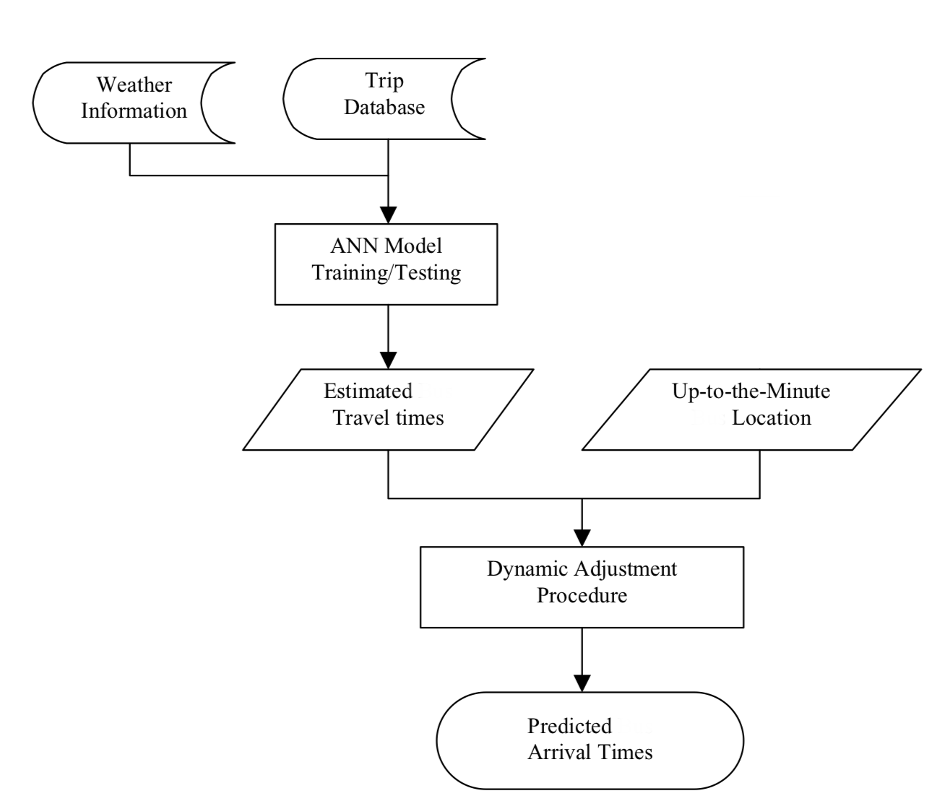

Among those variables that may contribute to the variation of travel time, we select four input variables, day of the week, time of the day, weather, direction, station (speed and traffic status to be added at a later point in time). The output of the model is the travel times between two adjacent time points. The arrival time can then be calculated based on departure time and the estimated travel time.

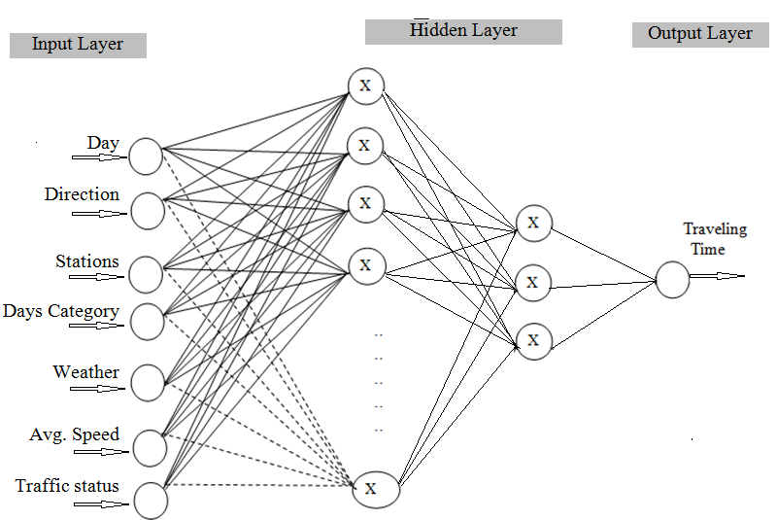

The training procedure chosen is the most commonly used back-propagation algorithm, whose learning process is shown below. The objective of the learning process is to find a weight matrix that minimizes the mean squared error (MSE), which is defined as the average squared error between the ANN predictions and the actual values of travel times. [6]

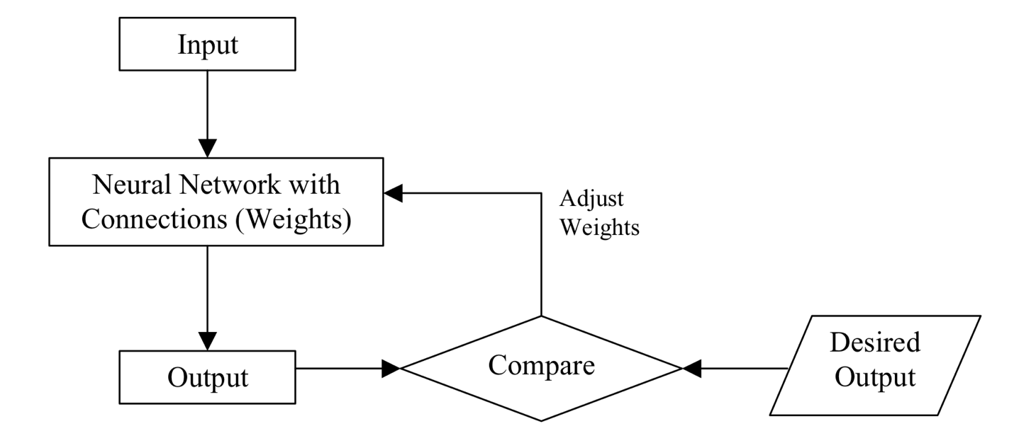

## 2.3 Tools

Describe the tool(s) you will use, or explain why you will build from scratch. Explain your choice. Show that you understand how the tools work.

1. Python – python is being used as the primary language because of my familiarity with the language and as it provides me with great Machine Learning libraries.

2. Spyder with Anaconda – I am using Spyder as my IDE for data collection, pre-processing and model creation. I use Spyder as it allows me a nice interaction with environment variables.

3. Libraries such as pandas, numpy, scikit-learn, google.transit etc will be extensively used for data collection and pre-processing.

4. Keras on top of TensorFlow will be the deep learning framework. TensorFlow is used as it’s widely used in the industry and Keras helps in quick prototyping.

5. Django framework in python will be used to deploy the project, I use this because of my extensive experience with framework so that I don’t spend more than 2-3 days for deployment.

## 2.4 Implementation Fragments

Show enough *parts* of an implementation—or a simplified form of it—to convince the reader that you will have the implementation of the definite requirements completed on time. These can be experimental or exploratory in nature. Your choices can coordinate with section 2.4 below. Cut and paste commented code below.

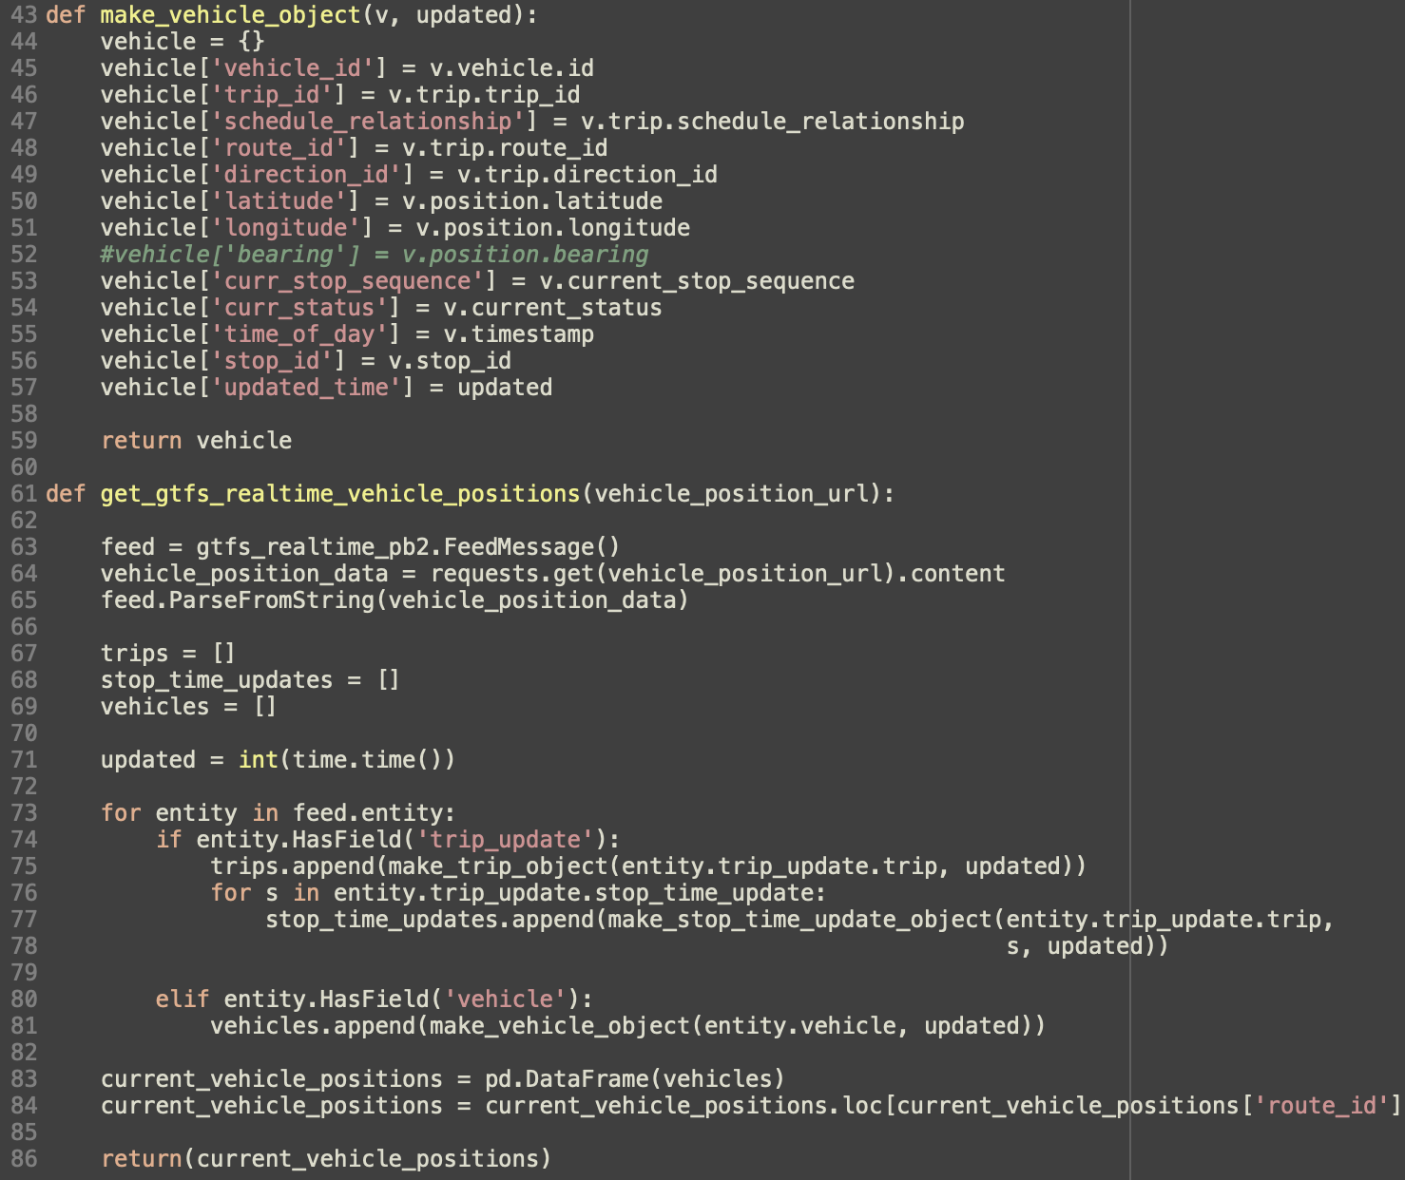

This is a currently implemented code fraction for the data collection process. The get_gtfs_realtime_vehicle_postions() generates the real-time positions of trains in the MBTA and the helper function make_vehicle_objects helps to create the object structure of each active vehicle. This code is also re-used to generate a week worth of historical data [4].

## 2.5 Risk Retirement

Identify and prioritize the 5 top risks in carrying out the project. Try as best you can to retire the top three by the time you submit this, by means of experiments, prototypes, or work-arounds. Explain how you did this. Explain how you will retire the remaining risks in advance.

1. Unable to access and process MBTA server data.

2. NN processing crosses the memory threshold.

3. Error rate with arrival time threshold more than +-2 mins.

4. Risk of inability to scale based on cities and mode of transportation.

5. Keras, TensorFlow and other libraries doesn’t link properly within the project.

6. Risk of deployment failure.

Retired –

1. Unable to access and process the MBTA server data.

## 2.6 Schedule

Explain in outline the steps you intend to take to carry out the project. Show the completion of the stages. Include a schedule, as detailed as can be reasonably foreseen.

October –

1. Learning basics of TensorFlow and Keras. Also looking into PyTorch - completed

2. Data collection - completed

3. Data pre-processing – mostly completed

4. Input and output determination have to be finalized – mostly completed

November -

1. First week – Continuing data-preprocessing and model creation

2. Second week – Training and dynamic algorithm creation

3. Third week - Implementation

2. Fourth week - Results measurement and deployment

## 2.7 References

## List the references to materials of all kinds that you used in developing this. Each should occur in the body of the text at the appropriate place.

[1] Dynamic Bus Arrival Time Prediction with Artificial Neural Networks, Journal of Transportation Engineering

[2] Bus-Arrival-Time Prediction Models Link-Based and Section-Based. Journal of transportation engineering

[3] Kalaputa, R. and Demetsky, M. (1995). Application of artificial neural networks and anutomatic vehicle location data for bus transit schedule behavior modelling.

[4]Xu. Jing Ying. Bus arrival time prediction with real-time and historic data.

[5] Tingting Yin , Gang Zhong , Jian Zhang , Shanglu He , Bin Ran. A prediction model of bus arrival time at stops with multi-routes multi-routes

[6] Mei Chen, Xiaobo Liu, Jingxin Xia & Steven I. Chien A Dynamic Bus-Arrival Time Prediction Model Based on APC Data

## 2.8 Evaluation of Design Phase



# IMPLEMENTATION

## 3.1 Summary

In a paragraph or two, summarize the outcome of your project functionally and learning-wise but avoid duplication with Section 3.3 below. (Reminder: leave these gray sections in your paper.)

The initial objective of the project was to implement a solution to minimize the bunching of trains, which is a very frequent occurrence in the Boston Subway system. Over the process of reading more about the topic over the past few months, I concluded that if I can build a model to predict the arrival time/travel time of the trains in the system, the initial problem can be solved eventually as a subset. We developed 4 models (OLS, GLM, XGBoost and a Dense Neural Network) to make the travel time predictions. All 4 models predict the segment route travel time with features computed directly from train GPS data, weather information and prior knowledge. The aim was to use limited information and implement innovative feature engineering methods from the limited existing data. This was done with the vision to scale the project easily to other cities with different API return parameters, vehicle routes etc.

The results show promising observations and insights into the travel time prediction using Global Position System data. XGBoost Regressor had the lowest errors on the hold-out test data with a MAPE of 7.7% and MAE of 59 seconds. The results also give insight into promising trends in errors when filtered by routes and peak/non-peak hours. In the final implementation of the Shiny app, arrival time predictions are made based on OLS, DNN, XGB, Moving average filter (MAV) and finally XGB+MAV. The combination of XGB and MAV seems to give the best results on real time data.

## 3.2. Report on Requirements

Describe the extent to which you accomplished each definite requirement "DiX" (X = F or L) as well as any other fulfilled requirements. For each, include 1-4 sentences and screenshot, as appropriate. Your effectiveness depends largely on how much you demonstrate that you learned, not necessarily that you implemented every requirement. Limit: 2 pages of 12-point Times New Roman.

## Create a model to predict train arrival times.

* I was able to create 4 models based on OLS, GLM, XGBoost and Dense Neural Network. I was fairly new to building Neural networks and this gave me a great opportunity to learn more about them. The model parameters, base code, results have been shown in the coming sections.

## The model should not require more than 5Gb of memory.

* The input data to the model was 230Mb in size. All the other intermediate files and model outputs combined, I was able to limit the whole project to 1Gb of required space.

## The model should have its Mean Absolute Error within 2 minutes.

* MAE of XGBoost Regressor was 59 seconds. 3.23 mins for OLS and 3.61 mins the least for Dense Neural Network. Requirements on errors helped me refresh my stats concepts and to empowered me to make decisions based on them. Error results are summarized in the below sections.

## The model should have its Mean Absolute Percentage Error within 20%.

* MAPE of XGBoost Regressor was 7.7 even though OLS and Dense Neural Networks were around the early 40s.

## Real-time dashboard with predicted arrival times for each stop.

* The dashboard was created using R shiny. This was a great tool to get more used to build easy to deploy web-apps. Evidence for building the app is show in the below sections.

## System should be scalable to different cities.

* Even though I modularized most of the functionalities of the system, it still requires to invest time to expand this to another city. Helped me learn more refactoring techniques to effectively manage codes.

## System should be scalable to different transportation mediums.

* Currently the system is set to predict rapid transit system within Boston. This could have been expanded to buses, ferries etc. which I was unable to achieve given the time constraints.

## System should be able to recommend drivers whether to go slow or fast based on the model to minimize train bunching.

- This was one of the initial ideas for the end product. This is a work that can be done with relative ease from the current state of the project.

## 3.4. Report on Design

Describe the design that you finally used. Indicate how, where, and why it differed from your planned design. Describe its advantages and its shortcomings. Include a description of how the technologies you explored (not the tools—those are described below) leveraged each other. Include at least one diagram. Limit: 2 pages of 12-point Times New Roman.

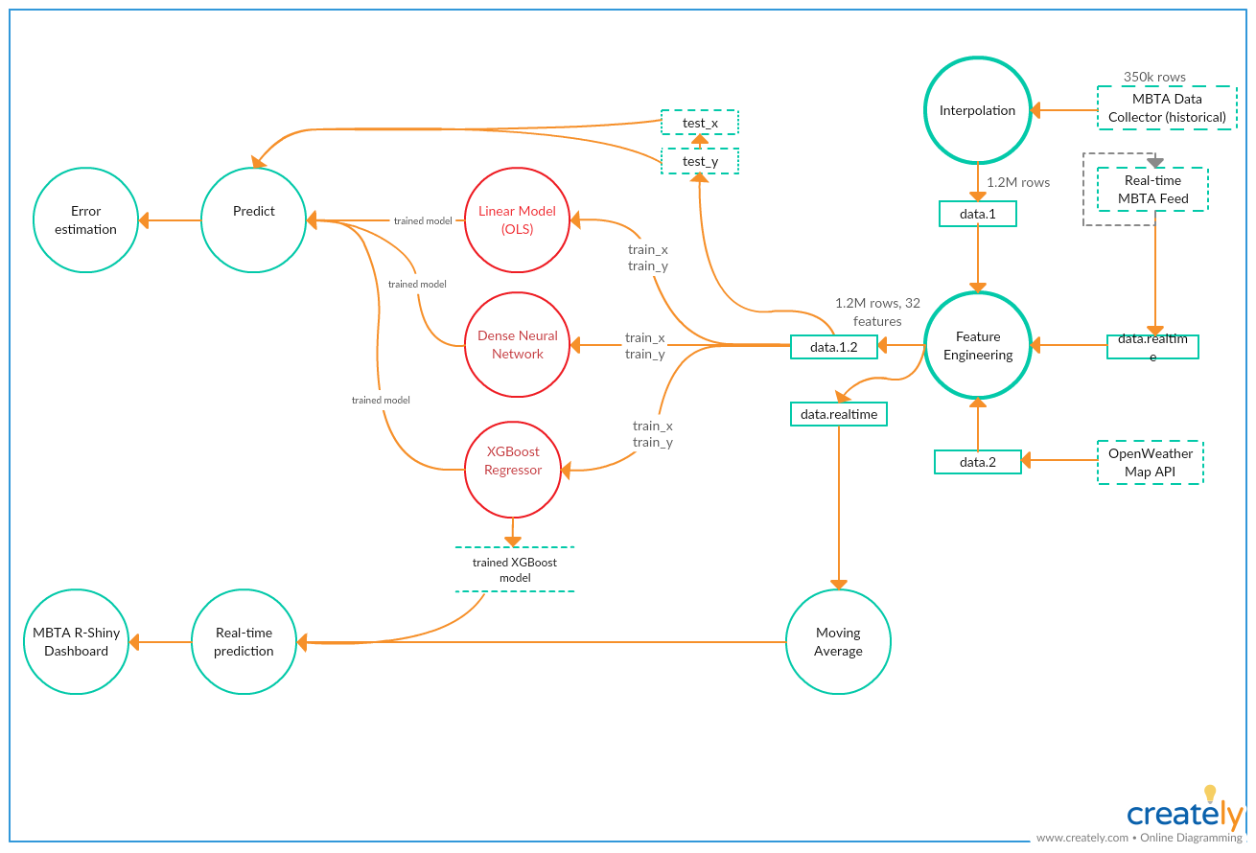

The MBTA Data Collector is a cronjob that was run over the first week of November, 2018. The task of the Collector was to ping the MBTA servers for vehicle locations once every minute and save that data. The Real-time MBTA feed data is a real-time feed of the vehicle location when the system is actively deployed. OpenWeatherMap API is an api for accessing realtime and historical weather data.

Models – Ordinary Least Squares, Generalized Linear Model, XGBoost Regressor with an n_estimator of 10 and maximum of 6 levels, Dense Neural Network using 3 layers, compiled using mean absolute error as the loss function and adam as the optimizer. Also, between each two layer a dropout layer is added to minimize overfitting with RELU and softmax as the activation function.

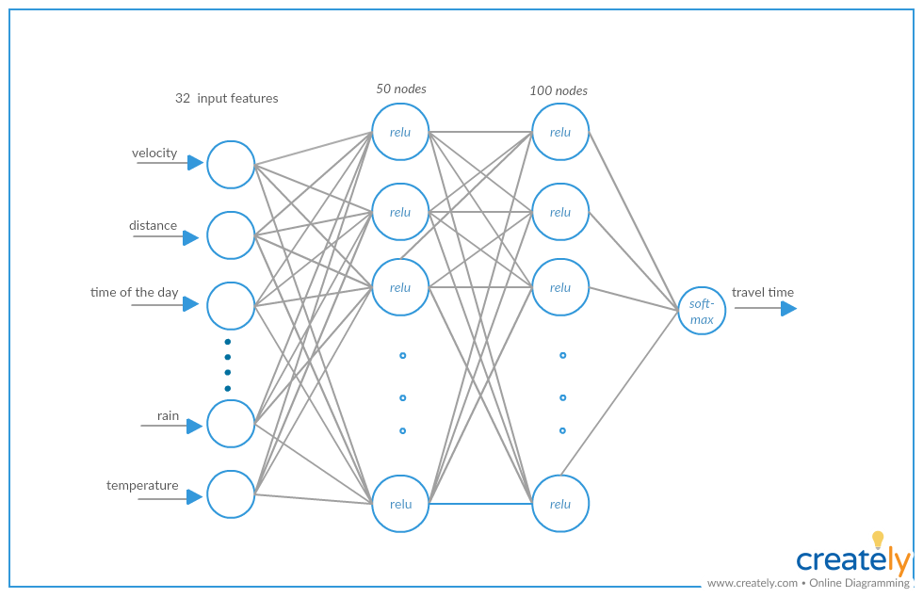

The Data from the MBTA Data collector is our historical data which will be passed onto all the Machine learning models I mentioned earlier. The cleaned version of the historical data comprises of approximately 350k rows with 12 features including vehicle ID, latitude, longitude, route ID, server time, system time etc. We traverse the journey of each train one-hop into the future in-order to generate the fields start_lat (latitude), start_lat (longitude), end_lat (latitude of the one-hop entry), end_lon (longitude of the one-hop entry). This also allows use to calculate the distance travelled by the train using the start and end coordinates, travel time using the difference in server time.

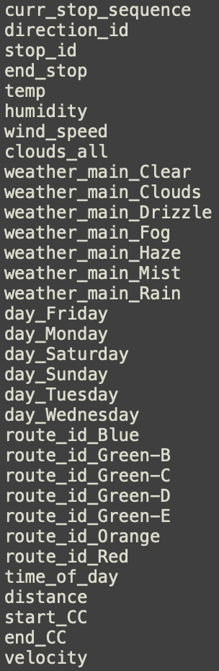This 350k data points is then passed onto the Interpolate functionality. We use the segment travel time (travel-time between two consecutive pings to the MBTA server) to generate two-hop, three-hop segments by following each trains journey. This creates a 1.2M data-set within a uniform distribution. Historical weather information is joined to this data-set using the OpenWeatherMap API. Feature engineering to calculate fields like distance from the city center, velocity, time of the day etc. are done after this step.

Now we have the clean engineered 32 features and the target variable “travel time”. This data is normalized, split into 70% train and 30% test and fed into each of the 4 models. Errors like Mean Bias Error, Mean Absolute Error, Mean Absolute Percentage Error and Root Mean Squared Error are computed using the hold-out test dataset for each model for comparison. The best model is saved into the system for real-time prediction.

The real-time MBTA R Shiny dashboard takes the real-time feed of the vehicle locations. For each live train currently present in the system, depending on the inbound/outbound direction all possible stop locations are processed into the real-time data. The velocity of each train is calculated using a moving window function which keeps track of the previous 10 data points of the train. This data is fed through the same feature engineering functions and is used to predict the travel time using the model with the best error parameters. The results of the prediction are then loaded onto the Shiny dashboard at 30s,1m or 5m intervals.

## 3.5. Tools

Describe the machine learning tool(s) that you used. Show samples. Describe their advantages and their shortcomings. (List other tools separately.) Limit: 1 page of 12-point Times New Roman.

1. **Ordinary Least Squares (OLS)** - In statistics, OLS is a type of linear least squares method for estimating the unknown parameters in a linear regression model. OLS chooses the parameters of a linear function of a set of explanatory variables by the principle of least squares: minimizing the sum of the squares of the differences between the observed dependent variable (values of the variable being predicted) in the given dataset and those predicted by the linear function. OLS from statsmodel is used. OLS is a bit sensitive to the outliers. It cannot describe non-linear relationships.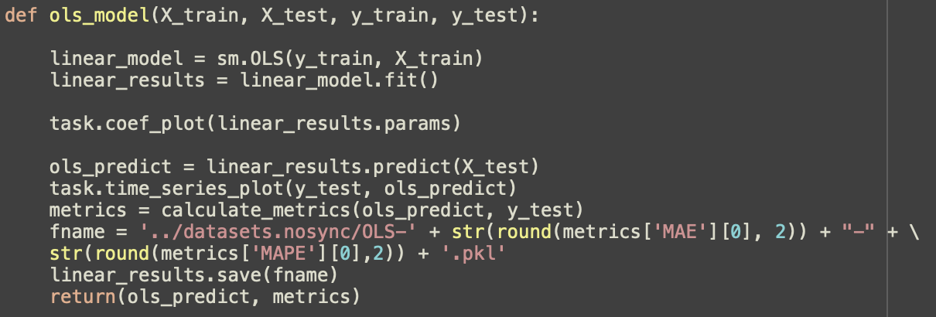
2. **Generalized Linear Model (GLM)** - In statistics, the generalized linear model (GLM) is a flexible generalization of ordinary linear regression that allows for response variables that have error distribution models other than a normal distribution. The GLM generalizes linear regression by allowing the linear model to be related to the response variable via a *link function* and by allowing the magnitude of the variance of each measurement to be a function of its predicted value. GLM from statsmodel is used to build the model. Major shortcoming of GLM from the results is that it failed to identify the outliers in the data-points. Not detecting extreme travel-times is really bad for this case scenario where we don’t want the traveler to miss the train.

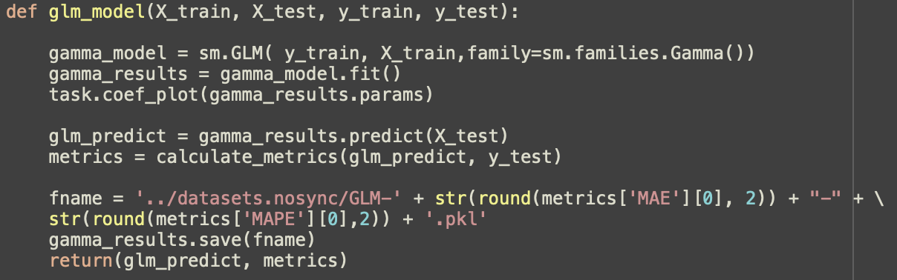

1. **XGBoost Regressor (XGB)** – **XGBoost** is an optimized distributed gradient boosting library designed to be highly **efficient, flexible**and**portable.** It implements machine learning algorithms under the Gradient Boosting framework. XGBoost provides a parallel tree boosting (also known as GBDT, GBM) that solve many data science problems in a fast and accurate way. The following parameters are passed on to the mode –
   1. n estimators – 100 (number of trees)
   2. Learning rate – 0.05 (step size shrinkage used in update to prevent overfitting)
   3. Max depth – 6 (maximum depth of a tree)

Xgboost library is used to build the model. The code snippet for the implementation is shown in Sample Source.

1. **Dense Neural Network (DNN)** - The DNN is created using 3 layers. Model is compiled using mean absolute error as the loss function and adam as the optimizer. Also, between each two layer a dropout layer is added RELU and softmax are used as the activation functions. The following hyperparameters are passed on to the model –
   1. Loss – mean absolute error
   2. Optimizer – adam
   3. Activation functions – relu & soft_max
   4. Dropout – 0.5
   5. Validation Split – 0.2
   6. epochs – 100
   7. Batch Size – 1003.6 Contrast between approaches

Keras library is used to build the model. Keras is an open source neural network library written in Python. It is capable of running on top of TensorFlow, Microsoft Cognitive Toolkit, or Theano.The code snippet for the implementation is shown in Sample Source. The shortcoming of the DNN was it failed to recognize the time series nature of the data. Better models like LSTM would ideally be a better fit for the given problem statement.

Other tools –

1. **R Shiny** - Shiny is an open source R package that provides an elegant and powerful web framework for building web applications using R. Shiny was used to build the real-time MBTA dashboard to show the real time locations and next expected inbound and outbound arrival times using the implemented ML model.

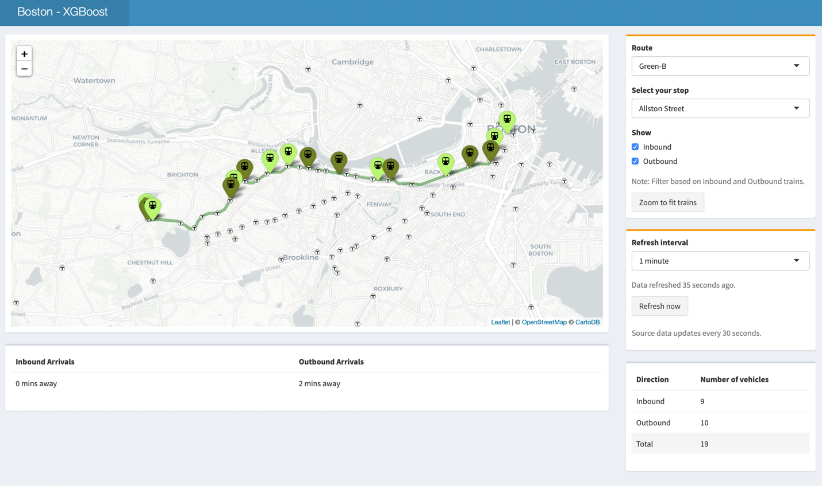

This is the dashboard view of the application –

* Route – Gives you an option to filter based on MBTA Rapid transit routes. Example – Green-B, Red, Orange etc.
* Select your stop – Gives you the option to select the stop for which you want to see the next inbound and outbound arrival times. Example – Boston University West, Park Street etc.
* Refresh Interval – Update frequency for the map and the arrival times.
* Inbound, Outbound filters – filters the map based on the entry.

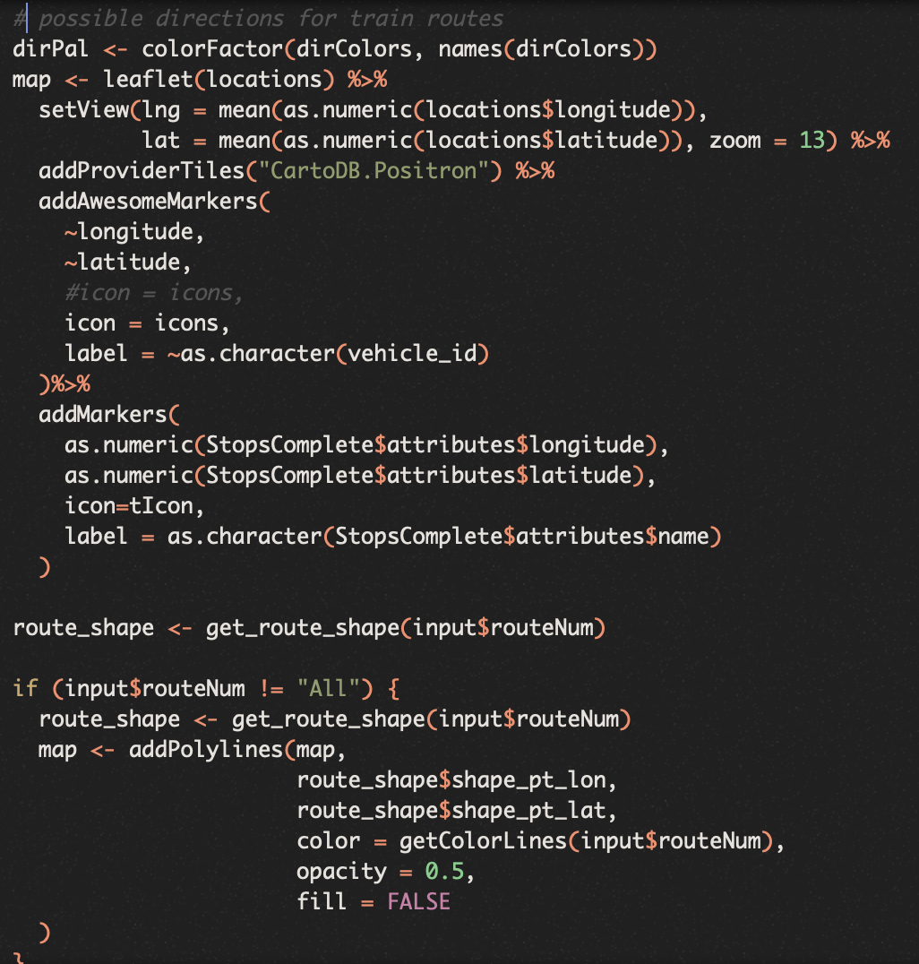

RShiny code snippet where markers are generated using LeafletJS.

1. Leaflet - Leaflet is a widely used open source JavaScript library used to build web mapping applications. Used for mapping in the Shiny application.
2. Plotly – Visualization library in python and R. Used for generating graphs.

## 3.6 Contrast between approaches

You were to include two approaches to your problem, and implement at least one. Contrast the two approaches as they specifically relate to your project.

|  |  |  |  |  |  |
| --- | --- | --- | --- | --- | --- |
|  | MEANy (sec) | MBE | MAE (sec) | MAPE (%) | RMSE |
| OLS.all | 710.76 | -1.04 | 194.08 | 44.21 | 250.99 |
| GLM.all | 712.5 | 7.15 | 283.43 | 38.56 | 5936.15 |
| XGB.all | 711.98 | 54.8 | 58.79 | 7.7 | 83.77 |
| DNN.10% | 713.26 | -7.97 | 217.94 | 43.06 | 273.21 |
| DNN.50% | 712.77 | 38.41 | 248.63 | 45.7 | 320.07 |
| DNN.all | 713.14 | 11.55 | 268.74 | 53.45 | 338.08 |

1. **MEANy** – Mean of the y_test values.
2. **MBE** - Mean Bias Error measures the average difference between predict travel time and real travel time. Positive error and negative error will cancel out.
3. **MAE** - Mean Absolute Error measures the average derivation of prediction from real travel time.
4. **MAPE** - Mean Absolute Percentage Error measures the average percentage derivation from real travel time.
5. **RMSE** - Root Mean Squared Error measures average derivation. Compared to Mean Absolute Error, RMSE puts large weights on large errors.

The different approaches taken to solve the problem statement was to pass the data through 4 different models and pick the best one for real-time prediction. The Error results show that XGBoost Regressor does the best with a MAE of 59 seconds and MAPE of 7.7%. It is also noted that GLM has a really high RMSE value, corresponding to its inability to identify outliers even if it’s MAPE is just 39%. OLS does a pretty good job for a linear mode with 194 seconds MAE and 44% MAPE. Having a low MBE shows that it could be cancelling out the positive and negative errors. The Dense neural network goes down with increased data load which was an unexpected result. This probably explain the fact that DNN was unable to identify the time series nature or the data, or it may have started overfitting.

## 3.7 What did *not* work well

Explain the most important aspects of your project that fell short of your plans or desires.

* Dense Neural Network - I believe LSTM networks would be a better fit for this problem. As I added more features, the accuracy of the network did improve but it kept reducing as I added more data points. I suspect the model might be overfitting. Networks like LSTM which can handle time series data much better, will be a better approach to this problem statement.
* GLM - High RMSE shows that the model does not do well to predict the outliers. This is bad for the problem statement as we want to avoid the person missing the train. Due to this reason, I went against moving ahead with the GLM model.
* Failed to get historical traffic information – Even though I made significant searches through the internet, I was not able to get historic traffic information for Boston. There was APIs for real-time traffic information though. One of the small steps to overcome this was to feed in distance from the location to the city center. As this distance increases, traffic should reduce. Still this is not an effective solution as traffic is one of the main factors that impact travel time of trains.

## 3.8 What *did* work well

In paragraph form, explain the most important aspects of your project that met or exceeded your plans or desires.

## XGBoost Regressor - model performed reasonably well with the hold-out test data. The model had a MAPE of 7.7% and MAE of 59 seconds, which was the best result I got from the test data.

## Integrating predictions to a RShiny dashboard – With a little more effort, I was able to build a platform where I could see the real-time impact of the models. This was a great experience for me to improve my overall programming skills as well.

## Inferences from Error – Route based and Time of the day based.

|  |  |  |  |  |  |
| --- | --- | --- | --- | --- | --- |
| Route | MEANy (sec) | MBE | MAE (sec) | MAPE (%) | RMSE |
| Red Line | 756.85 | 58.12 | 63.12 | 7.79 | 88.82 |
| Green-B Line | 687.23 | 52.94 | 55.85 | 7.65 | 78.09 |
| Green-C Line | 663.37 | 51.5 | 54.83 | 7.75 | 78.14 |
| Green-D Line | 650.2 | 50.04 | 54.07 | 7.6 | 79.17 |

We can see that the errors are higher in Red line. There is a clear pattern to how a fast a route is, Red line is considered to travel faster as there is no interaction with traffic in comparison with Green lines. This has contributed to the increased error rate as we see from the table.

|  |  |  |  |  |  |
| --- | --- | --- | --- | --- | --- |
| Time | MEANy (sec) | MBE | MAE (sec) | MAPE (%) | RMSE |
| 11am-3pm  (non-peak hours) | 712.34 | 54.53 | 58.69 | 7.74 | 81.35 |
| 4pm-8pm  (peak hours) | 641.25 | 48.83 | 53.58 | 7.92 | 75.94 |

Here we can see that MAPE increase more during peak hours. This is in sync with the results observed in [7] where peak and non-peak travel times where predicted using ANN and SVM models.

## 3.9 Presentation Materials

Prepare a presentation for the last class based on the above. Include a short demonstration. This should last no more than 15 minutes. Include in this report copies of the slides, two per page.

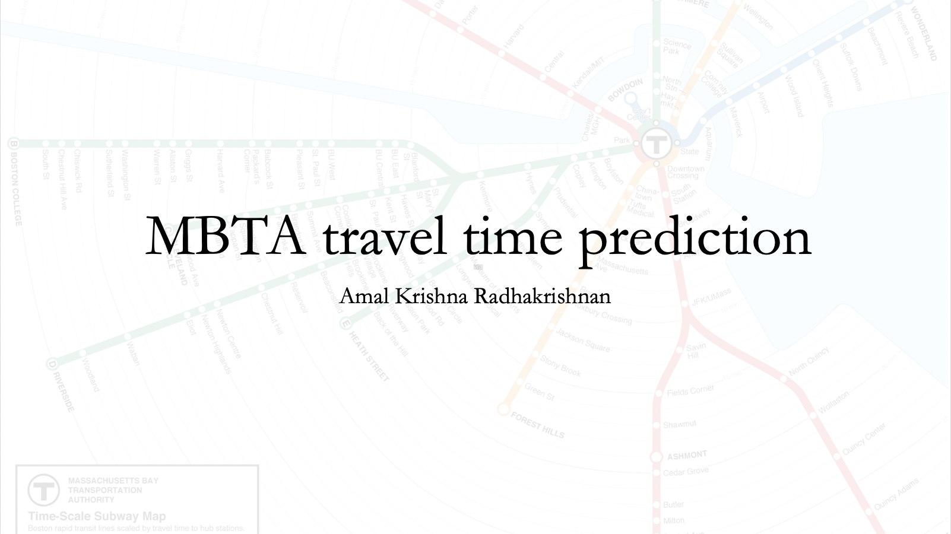

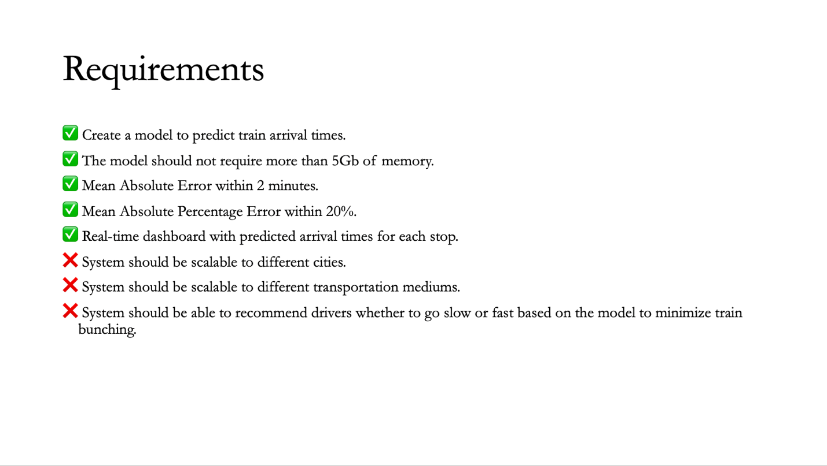

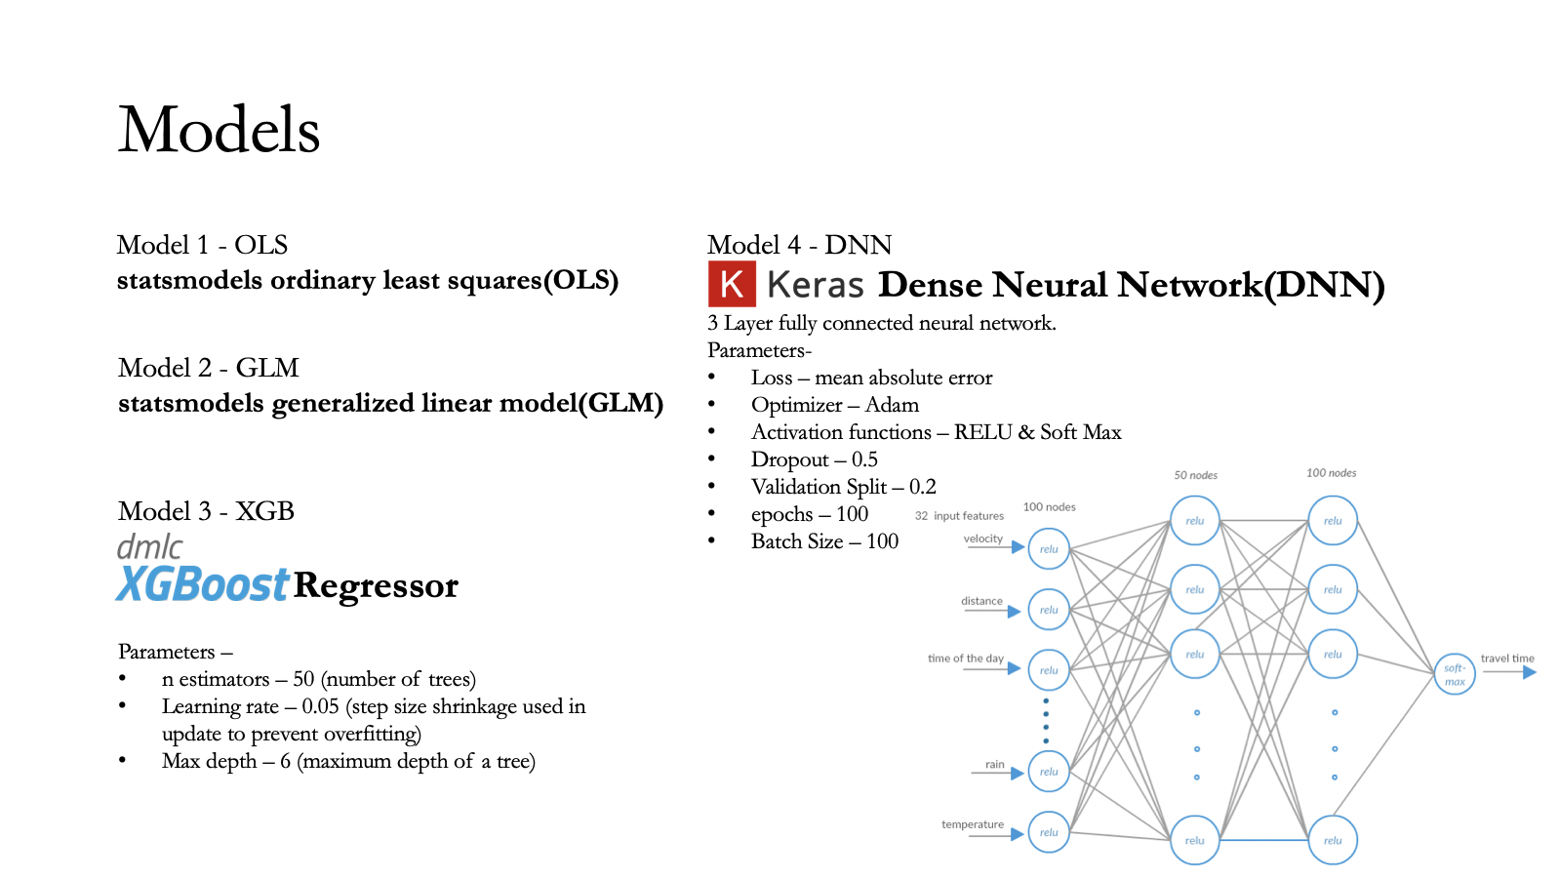

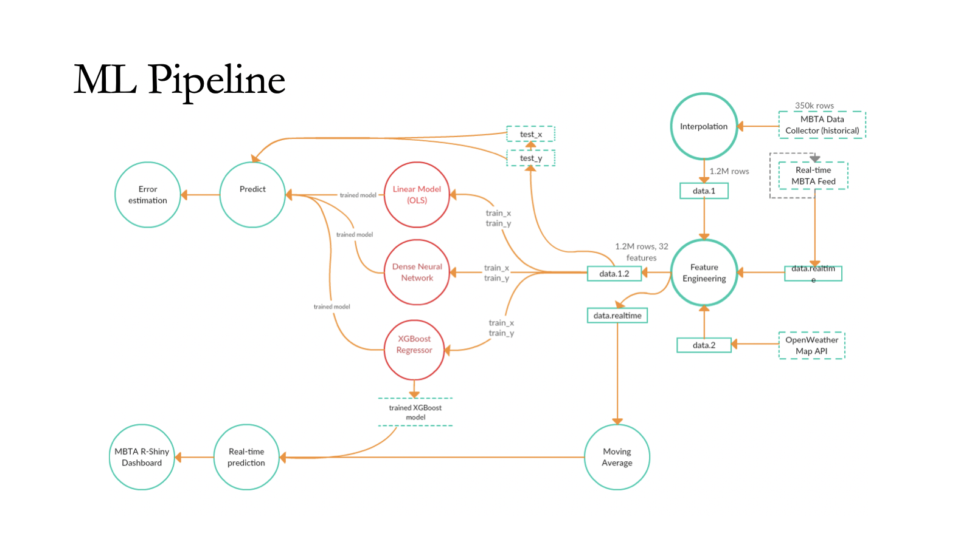

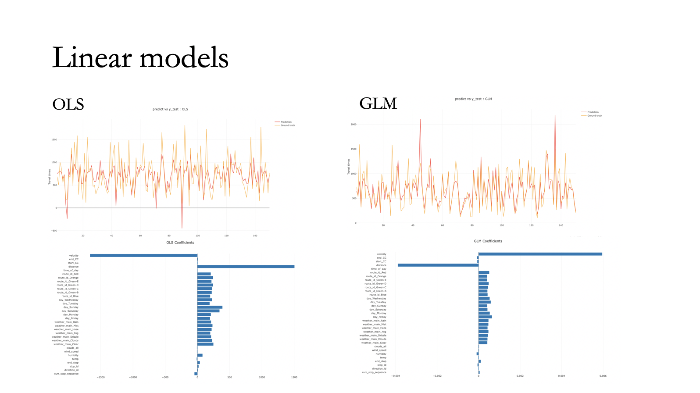

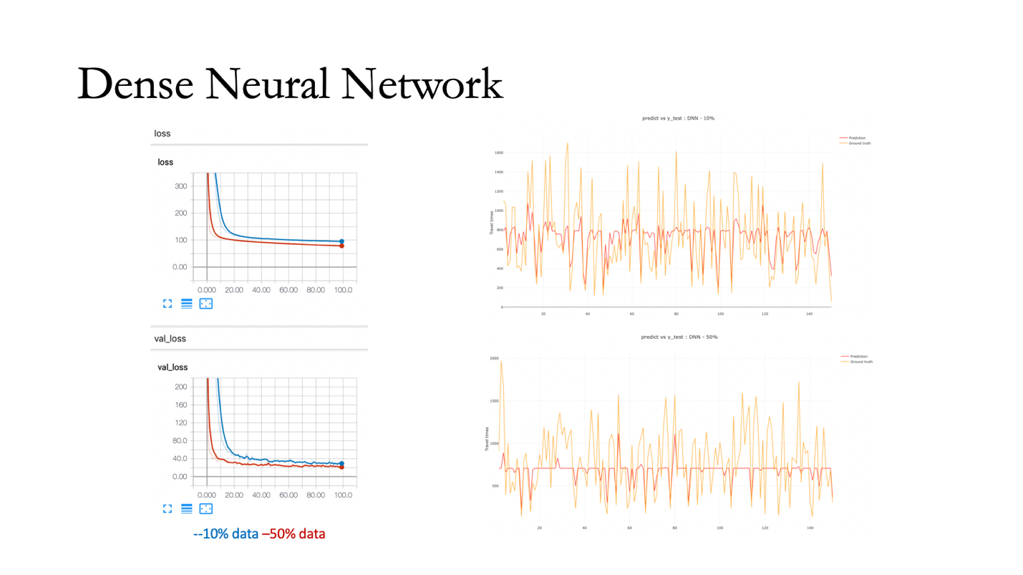

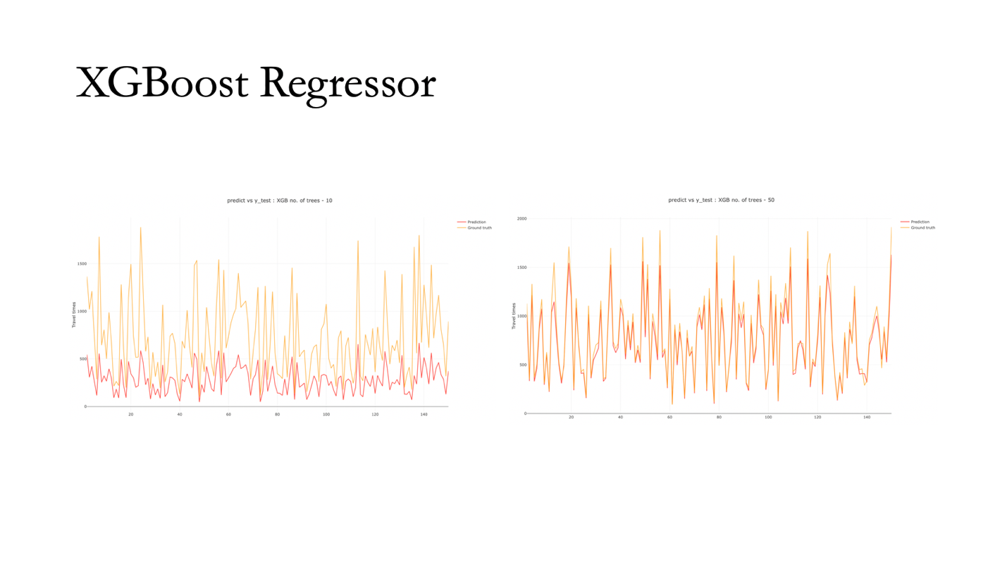

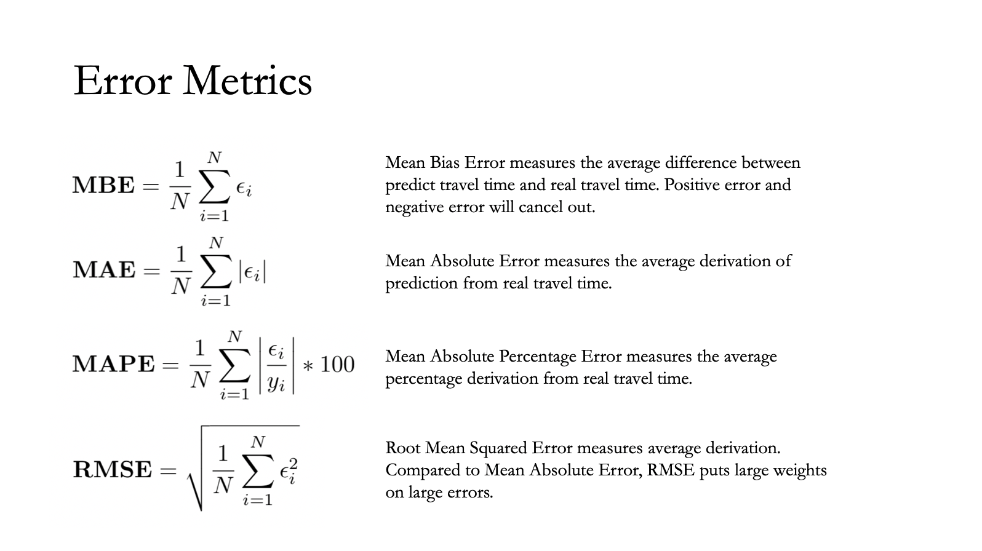

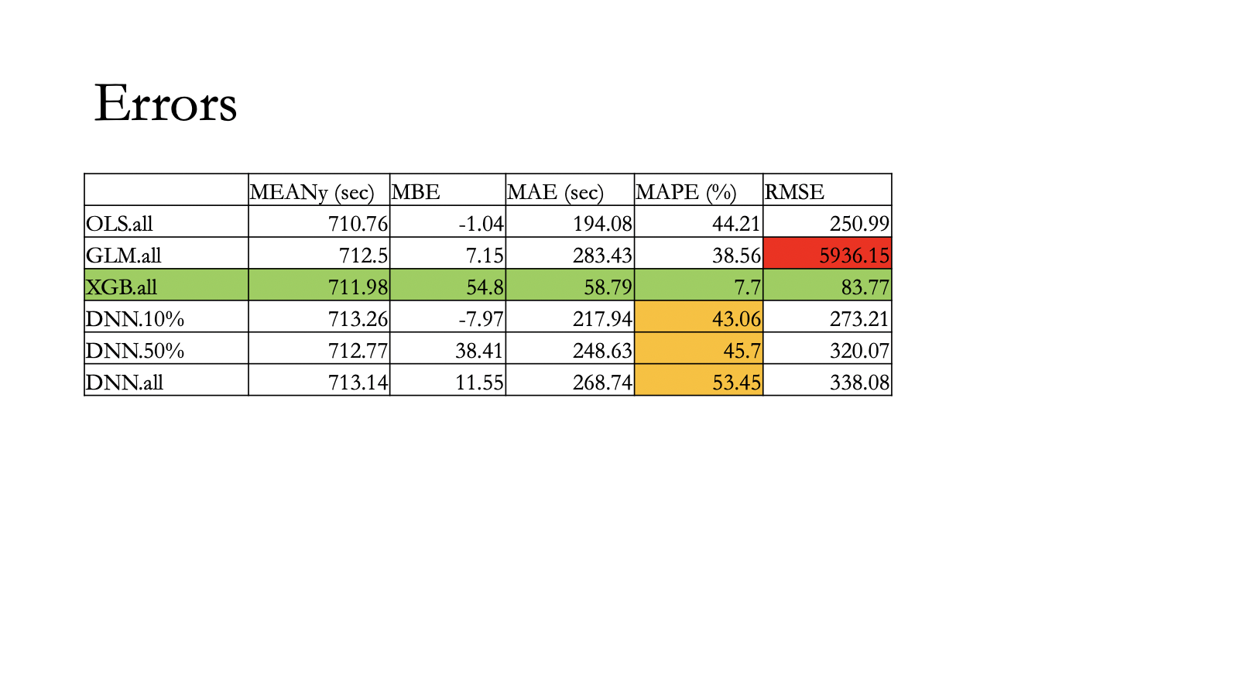

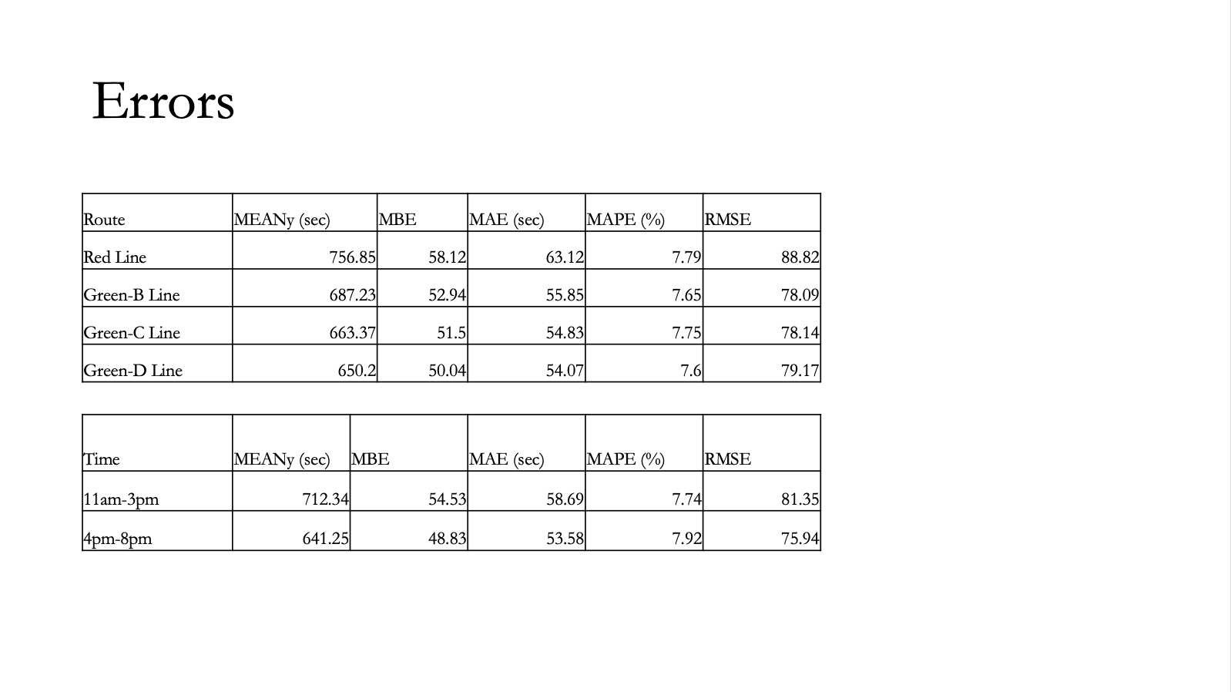

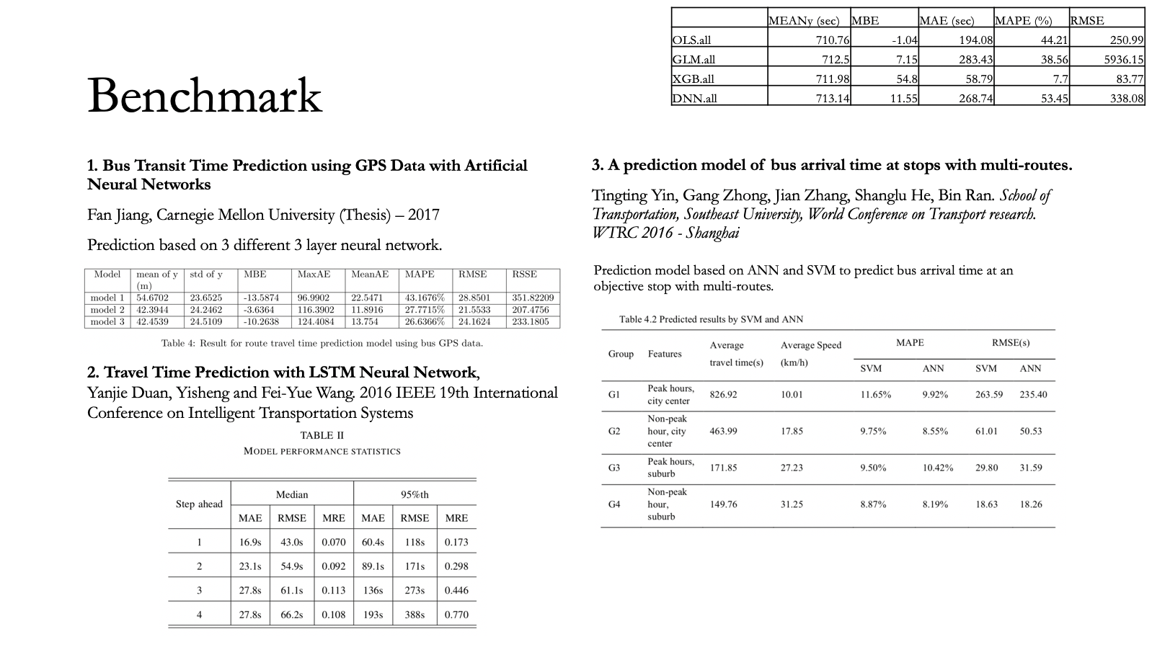

## 3.10 Sample Source

Supply up to 1 page of key excerpts from your source code—or what comes closest to “source code.” Limit: 2 pages of 12-point Times New Roman. Include an explanation of where the excerpts fit in your implementation.

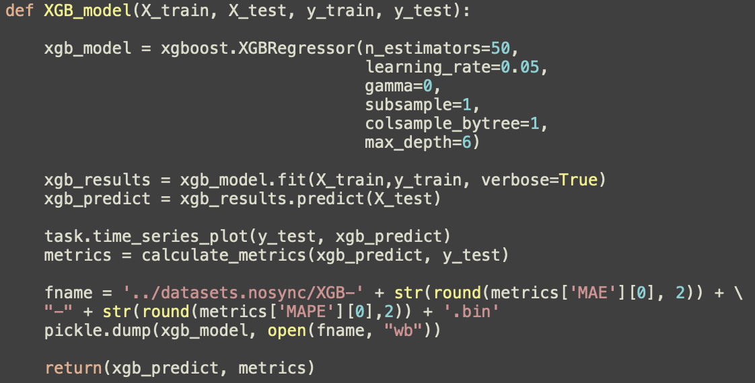

This is the implementation of the XGBoost Regressor. I have used 50 trees at a learning rate of 0.05 and a maximum depth of 6 levels.

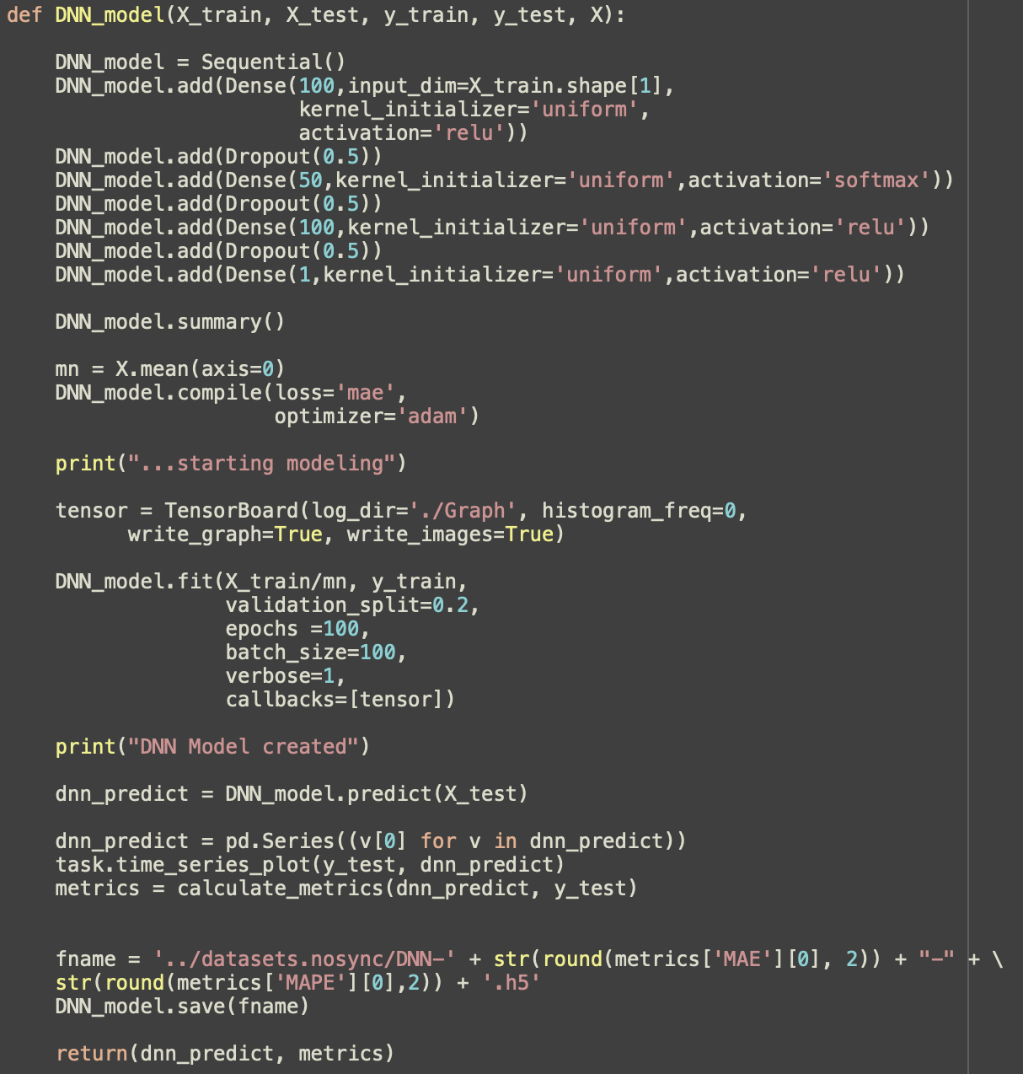

This is the implementation of the 3-layer Dense Neural Network. I have used the Keras library to build the model using Dense layers. Relu and Soft-Max are used as the activation functions. TensorBoard is used to visualize the loss.

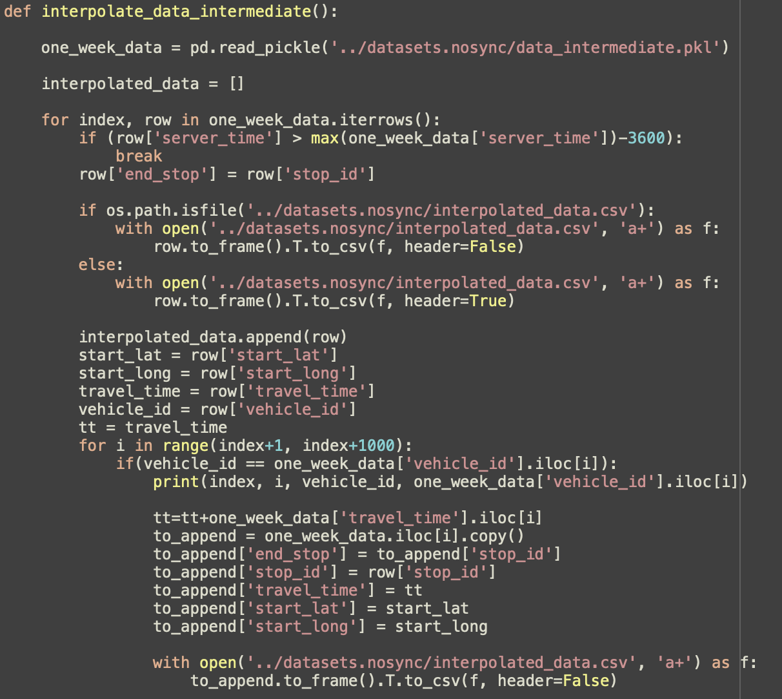

Standalone helper function for interpolation. The data after the processing of initial traversal to create the travel time, is passed on to this function. Since data is processing in large chucks, I have created 2 sets of intermediate data pickles to optimize running times. We pass through each row and for the specific train ID we go into the future to generate the on-hop, two-hop data-points traversed by the train.

## 3.11 Source

Attach source code (or what comes closest to it) and input where possible. You may refer the reader to github for source if you prefer.

<https://github.com/amalrkrishna/subway_time_prediction>

## References

Show that you used a wide variety of resources by listing them below and clearly indicating in the body above where you used them.

[1] Dynamic Bus Arrival Time Prediction with Artificial Neural Networks, Journal of Transportation Engineering

[2] Bus-Arrival-Time Prediction Models Link-Based and Section-Based. Journal of transportation engineering

[3] Kalaputa, R. and Demetsky, M. (1995). Application of artificial neural networks and anutomatic vehicle location data for bus transit schedule behavior modelling.

[4]Xu. Jing Ying. Bus arrival time prediction with real-time and historic data.

[5] Tingting Yin , Gang Zhong , Jian Zhang , Shanglu He , Bin Ran. A prediction model of bus arrival time at stops with multi-routes multi-routes

[6] Mei Chen, Xiaobo Liu, Jingxin Xia & Steven I. Chien A Dynamic Bus-Arrival Time Prediction Model Based on APC Data

[7] Tingting Yin, Gang Zhong, Jian Zhang, Shanglu He, Bin Ran. *School of Transportation, Southeast University, World Conference on Transport research. WTRC 2016 - Shanghai*

# Appendices

If necessary, supply one or more appendices with material that you want to make available. Appendices will be read on an as-needed basis only. They should be referred to in the body of the paper.

## Appendix 1: <title>

<your content here>

## Appendix 2: <title>

<your content here>

## Appendix 3: <title>

<your content here>

# Evaluation

